WINDOWS & LINUX SOC DETECTION REPORT

Detection 005 — Suspicious Account Creation
Wazuh • Windows Security • Linux Authentication Logs
Status | Investigation required
MITRE ATT&CK | T1136.001 — Local Account
Windows endpoint | window10 / 192.168.34.148
Linux endpoint | ubuntu_vm2 / 192.168.34.143
Rules | 100501 / 100510 / 100511
Date | 17 October 2026
Analyst | Vipin Kumar

1. Executive Summary
Wazuh detected local account creation on Windows and Linux. The dashboard search for rules 100501, 100510, and 100511 displayed 20 hits in the selected last-week range. The supplied alert details identify testuser_basic and testuser_sudo on Linux, and testuser_win and testuser_ps on Windows. Account creation is confirmed; unauthorized activity is not.

2. Environment
Wazuh manager: vm1
Windows endpoint: window10, agent 002, 192.168.34.148
Linux endpoint: ubuntu_vm2, agent 001, 192.168.34.143
Windows source: Security Event ID 4720
Linux source: /var/log/auth.log, useradd
Date: 17 October 2026

3. Detection Rules
Rule 100501: Windows local user account created, Level 10.
Rule 100510: Linux user account created, Level 8.
Rule 100511: Linux user account created with elevated privileges, Level 10.
All are mapped to MITRE ATT&CK T1136.001 — Create Account: Local Account.

4. Linux Finding — testuser_basic
Rule 100510, Level 8. Event time: 13:58:12.255546 UTC+05:30. Endpoint ubuntu_vm2 (192.168.34.143). UID/GID 1001; home /home/testuser_basic; shell /bin/sh. The useradd log confirms account creation; authorization and subsequent use are unknown.

5. Linux Finding — testuser_sudo
Rule 100511, Level 10. Event time: 13:59:24.485296 UTC+05:30. Endpoint ubuntu_vm2 (192.168.34.143). UID/GID 1002; home /home/testuser_sudo; shell /bin/bash. Although the rule description refers to elevated privileges, the raw useradd entry does not prove sudo group membership or sudoers access. Verify actual privileges.

6. Windows Finding — testuser_win
Rule 100501, Level 10. Windows Security Event ID 4720. Event time: 14:03:08.872 UTC+05:30. Creator: vipin. New account: testuser_win; target SID ends -1006; event record ID 46579. The event text reports the account as disabled and shows a Password Not Required flag. Verify the account's current state and policy before enabling it.

7. Windows Finding — testuser_ps
Rule 100501, Level 10. Windows Security Event ID 4720. Event time: approximately 14:03:59.299 UTC+05:30. Creator: vipin. New account: testuser_ps; target SID ends -1007; event record ID 46585. Authorization, enabled status, and group membership are not established.

8. Dashboard Summary
Query: rule.id:(100501 OR 100510 OR 100511). Selected range: Last week. Displayed count: 20 hits. This is the number of matching alert documents, not necessarily 20 unique accounts. Screenshots show activity on Windows and Linux agents and the Local Account MITRE category.

9. MITRE ATT&CK
T1136.001 — Create Account: Local Account (Persistence). This technique describes a behavior relevant to persistence investigations; it does not mean the observed account creation was malicious.

10. Analyst Verdict
Account-creation detections validated; authorization and privilege assignment require review. The records prove the four observed accounts were created and alert rules matched. They do not prove unauthorized access or malicious persistence. In particular, testuser_sudo's actual privileges must be checked.

11. Recommended Response
1. Confirm each account was deliberately created for the lab.
2. On Linux, inspect testuser_sudo group membership and sudoers permissions, plus /etc/passwd and /etc/group.
3. On Windows, check whether accounts are enabled and whether they belong to Administrators or other sensitive groups.
4. Review related password, enablement, group-membership, login, and command events.
5. If an account is confirmed unauthorized, preserve logs before disabling/removing it.
6. Validate the custom rule XML and test authorized account-creation cases to understand false positives.

12. Limitations and Conclusion
The custom rule XML was not supplied. The Linux useradd record does not establish group membership; the Windows account event does not establish later use. The dashboard count includes matching alert documents. Wazuh successfully detected account creation across both operating systems. Keep the case open until account authorization and privileges are verified.

Appendix A — Evidence Screenshots

E01-account-creation-dashboard.png
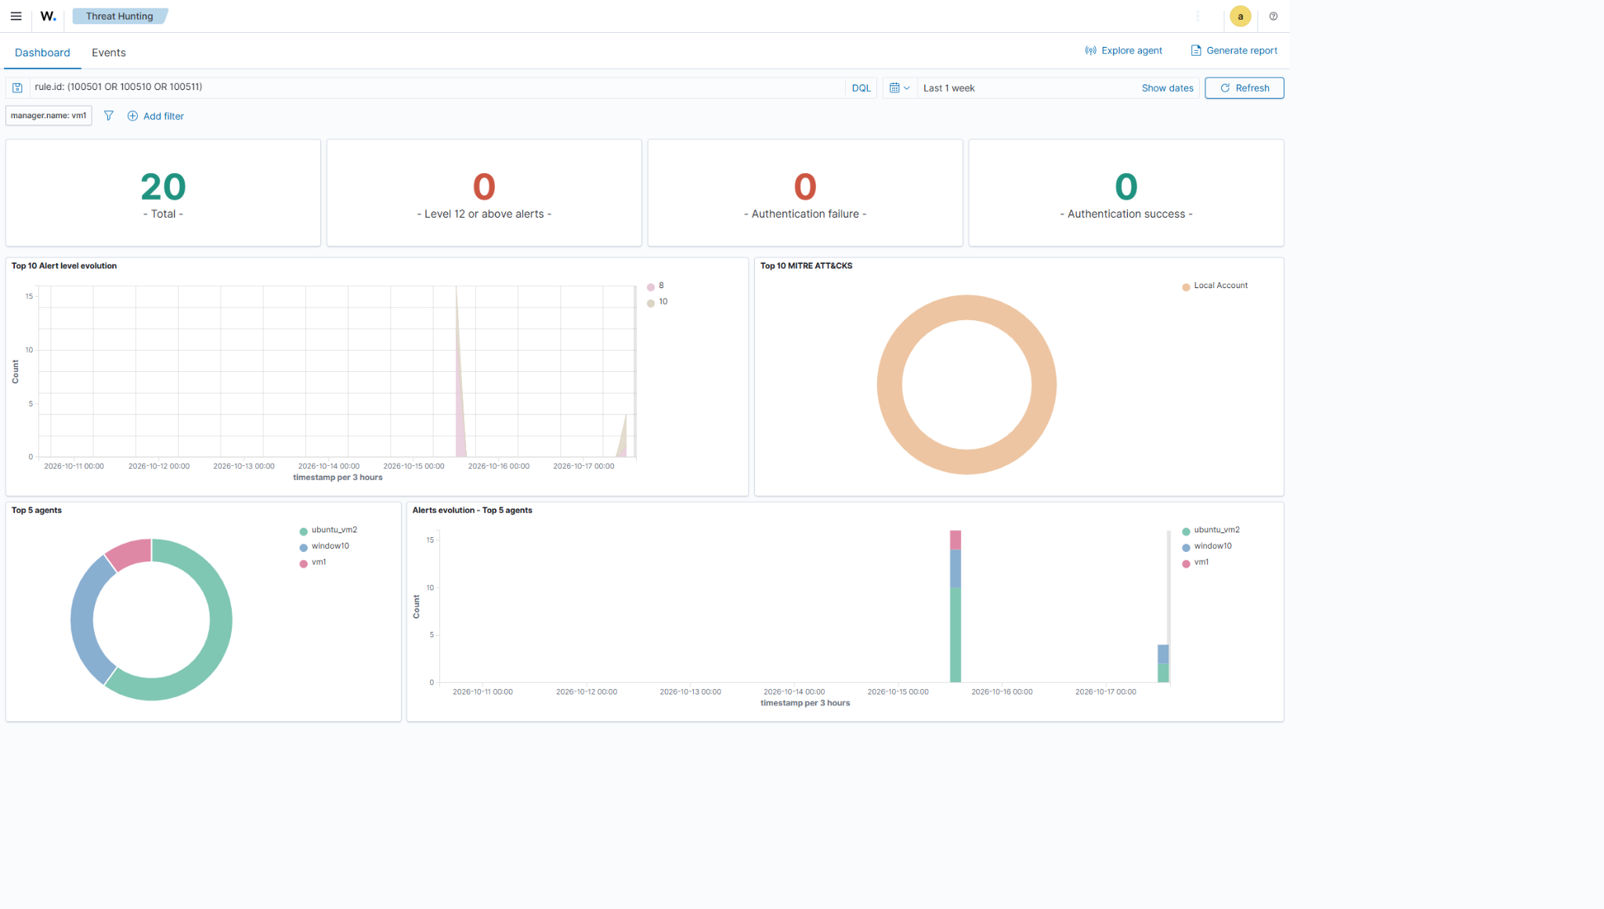

E02-account-creation-alerts.png
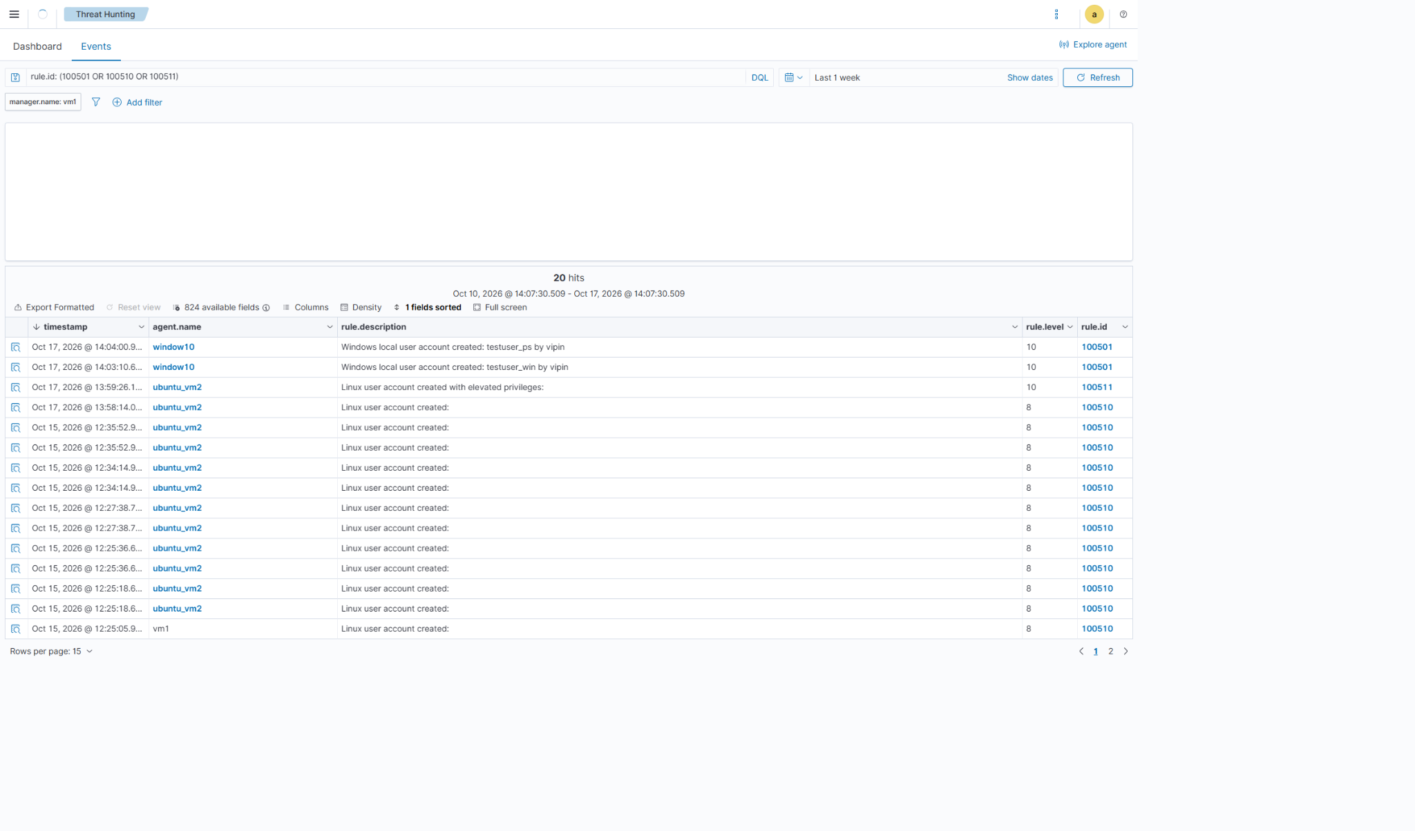

E03-linux-user-creation-elevated-rule.png
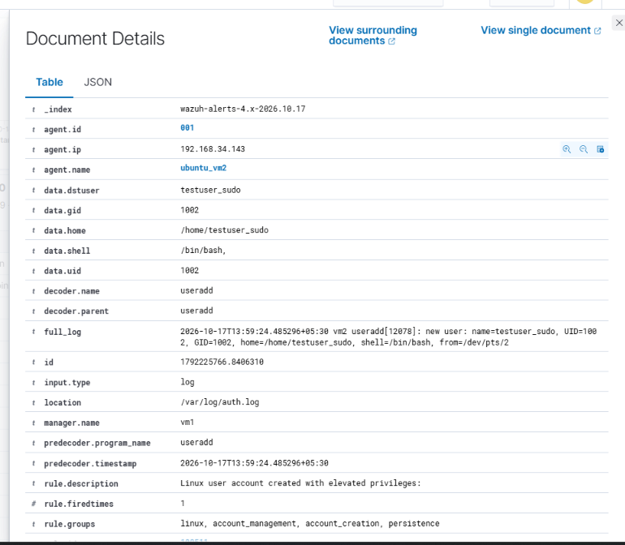

E04-windows-user-creation-details.png
